CI328 Introduction to Data Science and Big Data

Midterm Exam: 2/8/2021 at 12:00 PM (Closed book, Closed Notes, No Computer)

**Midterm Review**

Create the Python program to do following task

1. Display School Name (East-West University) in a field of 25 characters with right alignment

|  |  |  |  |  |  |  |  |  |  |  |  |  |  |  |  |  |  |  |  |  |  |  |  |  |
| --- | --- | --- | --- | --- | --- | --- | --- | --- | --- | --- | --- | --- | --- | --- | --- | --- | --- | --- | --- | --- | --- | --- | --- | --- |
|  |  |  |  |  | E | a | s | t | - | W | e | s | t |  | U | n | i | v | e | r | s | i | t | y |

ANS: print(f'{"East-West University":>25}')

1. Display floating point number (123456.789) in a field of 11 characters.

|  |  |  |  |  |  |  |  |  |  |  |
| --- | --- | --- | --- | --- | --- | --- | --- | --- | --- | --- |
|  | 1 | 2 | 3 | , | 4 | 5 | 6 | . | 7 | 9 |

ANS: print(f'{123456.789:11,.2f}')

1. Display integer number (12345678) in a field of 12 characters with comma.

|  |  |  |  |  |  |  |  |  |  |  |  |
| --- | --- | --- | --- | --- | --- | --- | --- | --- | --- | --- | --- |
|  |  | 1 | 2 | , | 3 | 4 | 5 | , | 6 | 7 | 8 |

ANS: print(f'{123456789:12,d}')

1. Display integer number (27) in a field of 10 characters with sign(+) and fill remaining characters of the field with 0s.

|  |  |  |  |  |  |  |  |  |  |
| --- | --- | --- | --- | --- | --- | --- | --- | --- | --- |
| + | 0 | 0 | 0 | 0 | 0 | 0 | 0 | 2 | 7 |

ANS: print(f'{27:+010d}')

1. Format the float value 17.489 rounded to the hundredths position by using String’s Format method

|  |  |  |  |  |
| --- | --- | --- | --- | --- |
| 1 | 7 | . | 4 | 9 |

ANS: print('{:.2f}'.format(17.489))

Lecture for 2-1-2021 (All)

Lecture 1-20-2021

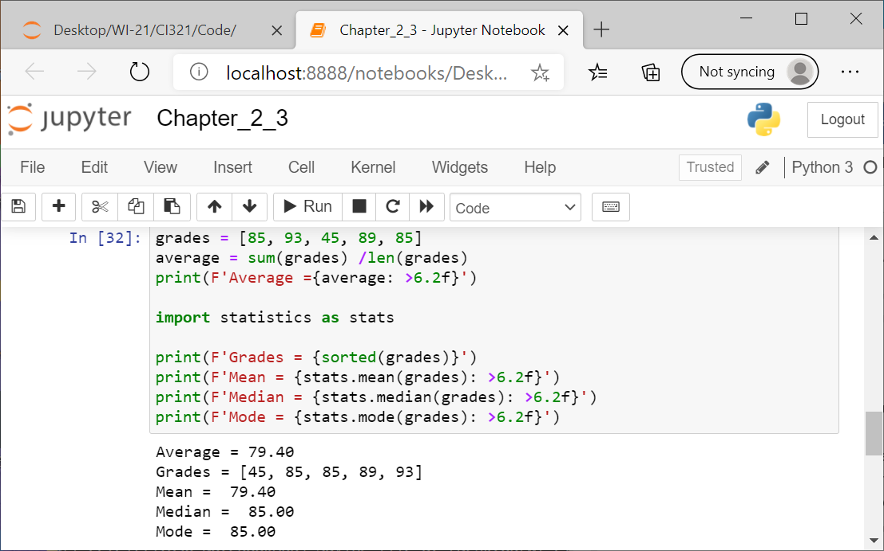

Lecture for 1-25-2021

